IMPORTANT 6th yr Careers UPDATES MAY 2020
CAO STATEMENT OF APPLICATION RECORD
All applicants should have received their CAO Statement of Application Record on May 15th – the text of the email sent can be viewed https://careersnews.ie/cao-statement-of -application-record/
It is very important that applicants check this document and notify CAO of any changes that need to be made immediately.
See school video or CAO website video on the topic here - https://www.cao.ie/index.php?page=video&l=417724441
CAO APPLICATION PROCESS
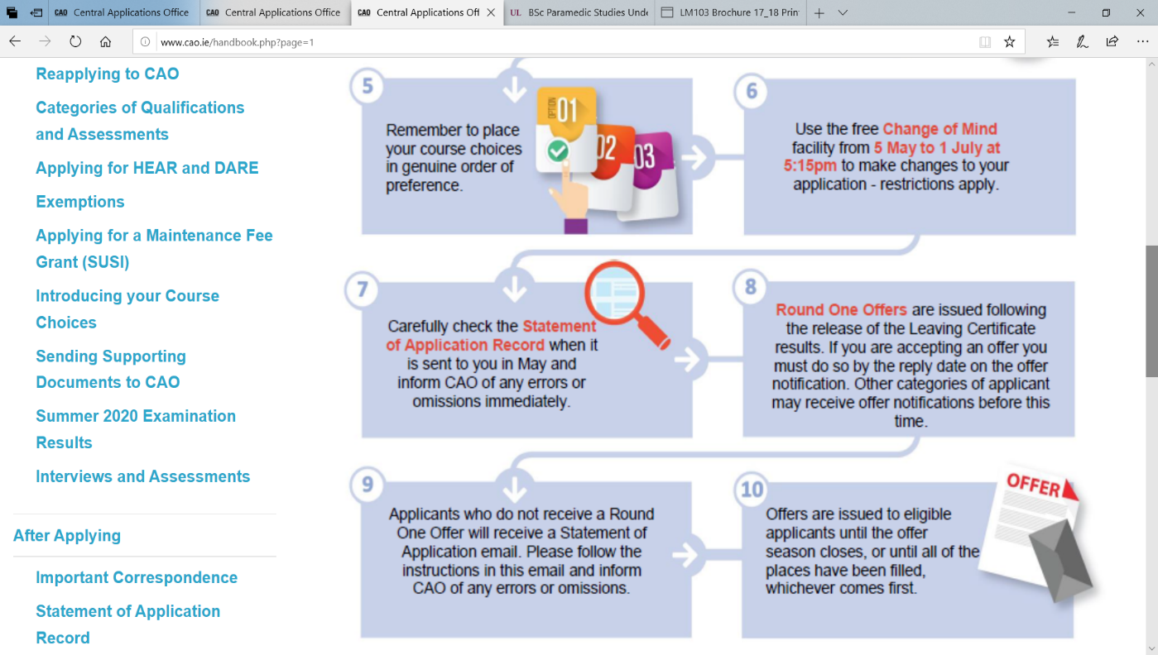

NEW CAO COURSES
There have been some new courses added for CAO 2020 that were not listed in the original handbook .
The only new course based in CORK is CIT’S Sport & Exercise Management Degree which will be of interest to many of you. See more at https://www.cit.ie/course/CR430
or https://www.cit.ie/cao/recordings where the CIT Dept Head goes through the programme.
List of all new courses available at www.cao.ie/handbook.php?page=changes

APPRENTICESHIPS & PLCS
All students wishing to apply for an apprenticeship should have their CV & Cover Letter ready to go for any opportunities that may arise.
Safe Pass courses may open soon. Covid 19 Safety Training needed for sites. Updates on Guidance Google Classroom stream.
Subscribe to indeed.com ,irishjobs.ie,monster.ie, careerservices.ie,apprenticeships.ie to be notified of opportunities – any vacancies we hear of will be posted on Google Classroom & Edmodo.
Don’t forget the Pre Apprenticeship Courses at www.stjohnscollege.ie & the Logistics and Accounting Apprenticeships @CIT see https://careersportal.ie/apprenticeships/index.php
PLCS ARE OPEN FOR APPLICATION – COLAISTE STIOFAN NAOFA will hold it’s interviews in September. It’s free to apply and many of the PLC courses have progression pathways into CAO courses.

